Title: NGUYEN VAN TU CUONGNGUYEN VAN TU CUONG

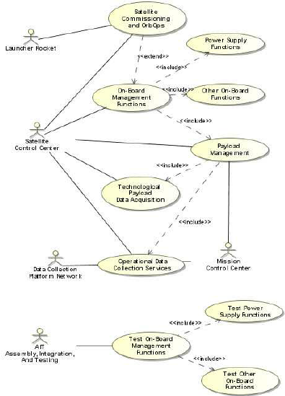

Author: 116399129664329115432

Topic: 116399129664329115432

Description: NGUYEN VAN TU CUONGNGUYEN VAN TU CUONGNGUYEN VAN TU CUONGNGUYEN VAN TU CUONGNGUYEN VAN TU CUONGNGUYEN VAN TU CUONGNGUYEN VAN TU CUONG CUONGNGUYEN VAN TU CUONGNGUYEN VAN TU CUONGCUONGNGUYEN VAN TU CUONGNGUYEN VAN TU CUONG

Content: NGUYEN VAN TU CUONGNGUYEN VAN TU CUONGNGUYEN VAN TU CUONGNGUYEN VAN TU CUONGNGUYEN VAN TU CUONGNGUYEN VAN TU CUONGNGUYEN VAN TU CUONGNGUYEN VAN TU CUONGNGUYEN VAN TU CUONGNGUYEN VAN TU CUONGNGUYEN VAN 123123